Ischioanal fossa

Location and shape
On the lateral part of the anal canal
Shape - pyramidal / wedge shaped
Apex - upwards and base - downwards

Boundaries
Anterior - posterior border of urogenital diaphragm
Posterior - lower border of gluteus maximus and sacrotuberous ligament
Medial - levator ani and external anal sphincter
Lateral - obturator internus and its fascia with ischial tuberosity below
Superior - apex is formed where obturator fascia meets the inferior layer of urogenital diaphragm
Inferior - floor is by perineal skin

Contents
- Ischiorectal pad of fat
- Inferior rectal nerve and vessels
- Perineal branch of S4
- Branches of posterior cutaneous nerve of thigh
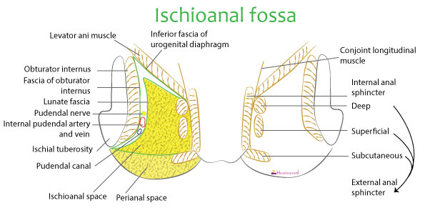
Boundaries
Anterior - posterior border of urogenital diaphragm
Posterior - lower border of gluteus maximus and sacrotuberous ligament
Medial - levator ani and external anal sphincter
Lateral - obturator internus and its fascia with ischial tuberosity below
Superior - apex is formed where obturator fascia meets the inferior layer of urogenital diaphragm
Inferior - floor is by perineal skin

Spaces around the ischioanal fossa

Ischioanal space proper
Region between perianal fascia and lunate fascia

Perianal space
Fat filled area between the skin and perianal fascia
Infection of this space - leads to perianal abscess

Suprategmental space
Space between the lunate fascia and apex of ischioanal fossa

Lunate fascia
Begins laterally at pudendal canal & merges medially with fascia covering deep part of external anal sphincter

Hiatus of Schwalbe
A gap between the tendinous origin of levator ani & obturator fascia is called Hiatus of Schwalbe.
Pelvic organs may herniate through this gap causing ischiorectal hernia

Pudendal canal = Alcock's canal
Contents of pudendal canal
Pudendal nerve
Internal pudendal vessels

Clinical importance - Ischioanal abscess
Infection of ischioanal fossa
Abscess usually has horshoe shape behind the anal canal

Goodsall's rule
Rule states that
- External opening anterior to a transverse line drawn across the anal verge is associated with a straight radial tract into the canal,
- External opening posterior to the transverse line follows a curved fistulous tract to the posterior midline rectal lumen
The fibres of levator ani arrangement is responsible for such a peculiar drainage pattern of these anal fistulas

